HWA CHONG INSTITUTION


C2 PRELIMINARY EXAMINATION
H1 CHEMISTRY 8872
PAPER 2

21 September 2010 2 hr

Candidates answer Section A on the Question Paper.
Additional Materials: Answer Paper
Data Booklet

READ THESE INSTRUCTIONS FIRST
Write your Centre number, index number and name on all the work you hand in.
Write in dark blue or black pen.
You may use a pencil for any diagrams, graphs or rough working.
Do not use staples, paper clips, highlighters, glue or correction fluid.

Section A
Answer all the questions.

Section B
Answer two questions on separate answer paper.
At the end of the examination, fasten all your work securely together.
The number of marks is given in brackets [ ] at the end of each question or part question.

FOR EXAMINERS’ USE ONLY
 |  |  | TOTAL
Multiple Choice | Section A  (Structured) | Section B  (Free Response) | 110
 | Q1 / 9 | Q5 / 20 | 110
 | Q2 / 9 | Q6 / 20 | 110
 | Q3 / 12 | Q7 / 20 | 110
 | Q4 / 10 |  | 110
/ 30 | Subtotal / 40 | Subtotal / 40 | 110

Section A
Answer all the questions in this section in the spaces provided.
1 | Copper and iodine are both shiny crystalline solids. They have the same face-centered cubic crystal structures.  The diagram shows the arrangement of the particles in this type of crystal lattice.
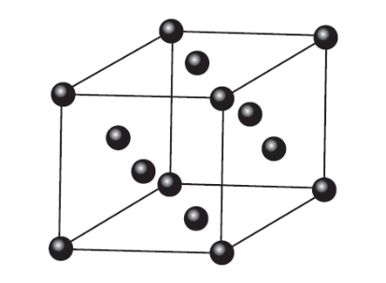
In the diagram above, the particles present are represented by .
 | (a) |  | Complete the table below about the type of particles and their interactions within the crystals.  [2]
  solid | type of particles | interactions within the crystals
  copper crystals
  iodine crystals
 | (b) |  | Explain briefly why copper is malleable and ductile.  ………………………………………………………………………………………………………  ………………………………………………………………………………………………………  [1]
 | (c) |  | Give another physical property present in one of the above solids but absent in the other. Explain your answer.
 |  |  | Physical property:
Reason:

………………………………………………………………………………………………………

………………………………………………………………………………………………………
[2]

 | (d) |  | A sample of copper contains the two isotopes ⁶³Cu and ⁶⁵Cu only. An experiment is conducted to find the relative atomic mass, A_{r}, of this sample and is found to be 63.9.
 |  |  | (i) |  |  | Explain why the value of A_{r} found is not a whole number.  ………………………………………………………………………………………………  ………………………………………………………………………………………………
 |  |  | (ii) |  |  | Suggest why the value of A_{r} stated above differs from the value given in the Periodic Table.  ………………………………………………………………………………………………  ………………………………………………………………………………………………  [2]
 | (e) |  | When separate beams of ⁶³Cu²⁺ and ¹²⁷I⁻ are passed through an electric field in the apparatus below, they behave differently.
 | 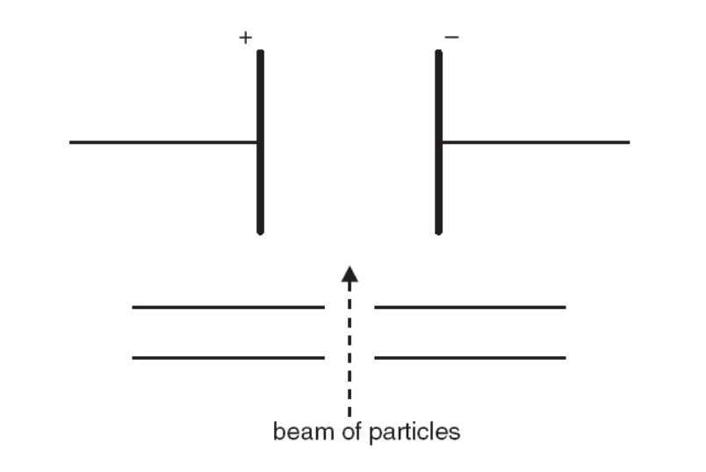
 |  | (i) |  |  | Sketch to show the paths of the beams of ⁶³Cu²⁺ and ¹²⁷I⁻ in the electric field on the above diagram.
 |  | (ii) |  |  | Given that the angle of deflection of the Cu²⁺ beam is 7.0º, calculate the angle of deflection of the I⁻ beam, correct to 1 decimal place.
 |  |  |  |  | Angle of deflection: _______________
[2]
[Total: 9]
2 | Bromoethane, C₂H₅Br, is hydrolysed by NaOH(aq). The rate of reaction can be determined by withdrawing samples of the solution containing C₂H₅Br and NaOH(aq) at known times, and titrating them with HNO₃(aq).  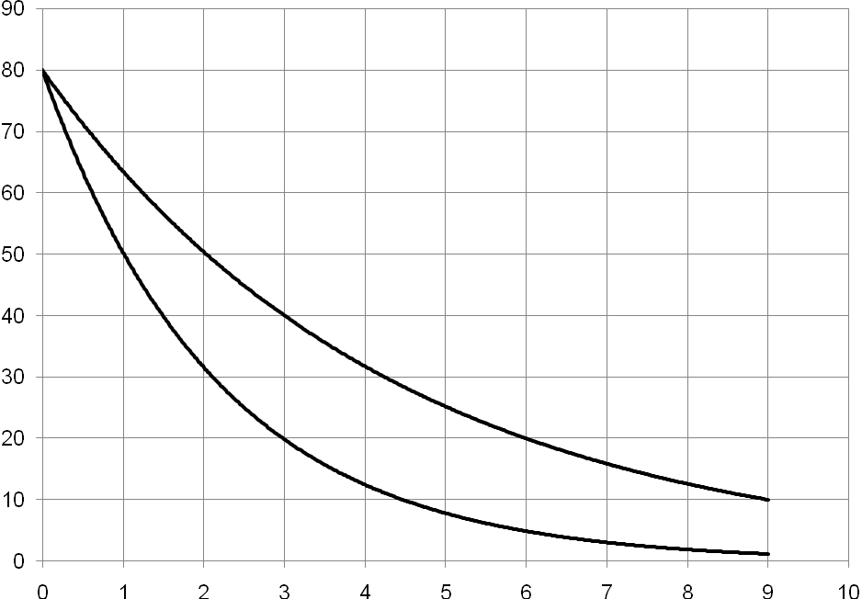  Two sets of experiments were performed where the initial concentration of C₂H₅Br was varied while the initial concentration of NaOH(aq) was kept the same at 0.1 mol dm^{–3}. The results obtained are shown in the graphs below.  Time / min  Volume of nitric acid / cm^{–3}  [C₂H₅Br] = 1.0 mol dm^{–3}  [C₂H₅Br] = 2.0 mol dm^{–3}  Volume of HNO₃ / cm³
 | (a) |  |  | (i) Using the graph where [C₂H₅Br] = 1.0 mol dm^{–3}, find the order of reaction with respect to NaOH(aq).
 |  |  |  | (ii) Using the graphs above, deduce the order of reaction with respect to C₂H₅Br.
(iii) Hence, write down the rate equation for this reaction.

[5]
 | (b) |  |  | With the aid of a sketch of the Boltzmann distribution in each case, explain why an increase in  (i) temperature,  (ii) concentration of C₂H₅Br,  increases the initial rate of the hydrolysis reaction.  (i)  …………………………………………………………………………………………………...…  ……………………………………………………………………………………………………...  ……………………………………………………………………………………………………...  (ii)  …………………………………………………………………………………………………...…  ……………………………………………………………………………………………………...  ……………………………………………………………………………………………………...  [4]
[Total: 9]

3 |  |  | (a) |  | (i) | Complete the following reaction scheme starting from compound B, CH₃COCH(OH)CH(CH₃)₂.  Write the structural formulae of all the organic compounds, C, E, F and G.
B
CH₃COCH(OH)CH(CH₃)₂
 |  |  |  |  |  |  |  |  |  |  |  | excess conc.  H₂SO₄, 170 ºC |  |  |  |  | F
 |  | D  CH₃COCH₂CCl(CH₃)₂ |  |  |  |  |  | HCl(g) |  |  | C |  |  |  | Step II
 |  |  |  |  |  |  |  |  |  |  | steam,  conc. H₃PO₄  high T and P |  |  |  |  |  | CH₃COCO₂H
 |  | Step I |  |  |  |  |  |  |  |  | E
conc. H₂SO₄,
heat
 |  |  |  |  |  |  |  |  |  |  |  |  |  |  | G
 |  |  |  | (ii) |  |  | State the reagents and conditions used in Steps I and II.
 |  |  |  |  |  |  |  |  | Reagents and conditions
 |  |  |  |  |  |  | Step I
 |  |  |  |  |  |  | Step II
 |  |  |  |  |  |  | [5]
 |  |  | (b) | Name the two functional groups in B and show how you would identify each functional group using a simple chemical test.
 |  |  |  | functional group |  |  |  |  |  | chemical test |  |  |  |  |  | observations
 |  |  |  |  |  |  | [4]
 |  |  | (c) | (i) |  |  | H, CH₃CO−C₄H₇, is a structural isomer of C which exhibits cis-trans isomerism. Draw and label the structures of this pair of isomers.
 |  |  |  | (ii) |  |  | Account for the existence of cis-trans isomers in H.  …………………………………………………………………………………………  ...………………………………………………………………………………………  ………...………………………………………………………………………………  [3]  [Total: 12]

4 | (a) | Ibuprofen is a non-steroidal ant-inflammatory drug for treating chronic arthritic pain of the joints. It is a white powder with a melting point of 74 – 77 °C. It is only slightly soluble in water but readily soluble in organic solvents such as ethanol.  To determine the amount in each tablet, the ibuprofen tablets are weighed, crushed and a known amount is dissolved in a solvent to prepare a standard 100 cm³ solution.  The solution is then filtered to remove the additives. A known aliquot of ibuprofen solution is then titrated against a standard solution of sodium hydroxide.  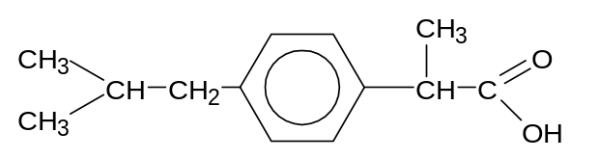  Ibuprofen
 |  | (i) | Write down the molecular formula of ibuprofen.
 |  | (ii) | Calculate the relative molecular mass, M_{r}, of ibuprofen and hence the mass of ibuprofen needed to make 100 cm³ of a 0.15 mol dm⁻³ solution.
 |  | (iii) | Oxidation of ibuprofen produces a dibasic acid J.  A solution containing 0.10 g of J required 12.0 cm³ of 0.10 mol dm⁻³ NaOH(aq) for neutralisation. Suggest a structure for J, showing your working.  [6]
 | b | (i) | Write an expression for the K_{a} for ibuprofen.  [You may represent ibuprofen using RCO₂H.]
 |  | (ii) | Calculate the pH of 0.15 mol dm⁻³ solution of ibuprofen.  [Given K_{a} for ibuprofen = 6.3 x 10⁻⁶ mol dm⁻³.]
 |  | (iii) | Use the data in the following table to suggest a suitable indicator for the titration of ibuprofen solution with aqueous sodium hydroxide. Justify your answer.  ……………………………………………………………………………………………  ...……………………………………………………………………………………………  ………...……………………………………………………………………………………  [4]  [Total: 10]
  indicator | pH at which colour changes
  methyl violet | 0 − 1
  methyl orange | 3 − 4
  bromothymol blue | 6 − 7
  phenolphthalein | 9 − 10

SECTION B
Answer two of the three questions in this section on separate answer paper.

5 | (a) | 5-hydroxypentanoic acid can undergo intramolecular esterification to form a cyclic ester, P, as shown.  HOCH₂CH₂CH₂CH₂CO₂H(l) ⇌ + H₂O(l)  5-hydroxypentanoic acid P  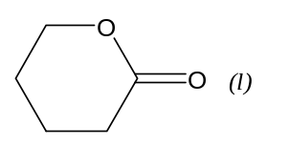  This esterification system exists in a dynamic equilibrium.
 |  | (i) | Explain what is meant by the term dynamic equilibrium.
 |  | (ii) | Write an expression for the equilibrium constant, K_{c}, for this reaction.
 |  | (iii) | In an experiment, 2.0 mol of 5-hydroxypentanoic acid was allowed to undergo esterification.  Given that 5% of 5-hydroxypentanoic acid remained at equilibrium and the total volume of the mixture remained constant at 200 cm³, calculate the K_{c} for this reaction, giving its units.  [4]
 | (b) | The decomposition of hydrogen peroxide is a first order reaction.  H₂O₂ → H₂O + ½O₂ ΔHº = −98 kJ mol⁻¹  The uncatalysed reaction has activation energy of 79 kJ mol⁻¹. Both the enzyme catalase and platinum act as catalysts and speed up the reaction.
 |  | (i) |  | Explain what is meant by each of the following terms.  I I order of reaction  II II activation energy
 |  | (ii) |  | Use the data provided to construct a reaction pathway diagram for the uncatalysed reaction.
 |  | (iii) |  | Describe how the activation energy is affected by the presence of enzyme catalase, and explain how this affects the rate of the decomposition of hydrogen peroxide.
 |  | (iv) |  | Suggest a simple method as how the rate of decomposition of hydrogen peroxide can be measured in the laboratory.  [7]
 | (c) | Compound Q, C₁₁H₁₄, exhibits cis-trans isomerism. Q reacts with hot acidified potassium manganate(VII) to give R, C₉H₈O_{3.} R reacts with aqueous alkaline iodine to give a yellow precipitate, S and a residual solution. Acidification of the residual solution yields benzene-1,2-dicarboxylic acid as shown below.  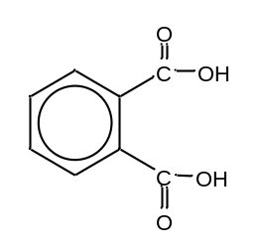  Q reacts with steam under suitable conditions to give T, C₁₁H₁₆O. T does not react with acidified potassium dichromate(VI).  Give the structural formulae of Q, R, S and T. Explain the reactions described and write equations for the reaction where appropriate.  [9]  [Total: 20]

6 | (a) | The chlorides of elements sodium to phosphorus all dissolve in or react with water. Two of the chlorides, magnesium chloride and silicon chloride, differ in their reactions with water.  Describe and explain these differences in terms of their structure and bonding, writing equations for any reactions that occur.  [4]
 | (b) | The table below gives the data on some oxides of elements in Period 3 of the Periodic Table.
  Oxide | Na₂O | MgO | Al₂O₃ | SiO₂ | P₄O₆ | SO₂
  Melting point / K | 1193 | 3125 | 2345 | 1883 | 297 | 200
  Boiling point / K | 1548 | 3873 | 3253 | 2503 | 448 | 263
 |  | (i) | Drawing diagrams where appropriate, suggest, in terms of structure and bonding, explanations for the following.
 |  |  | I |  | SO₂ has a low boiling point.
 |  |  | II |  | The melting point of MgO is higher than that of Na₂O.
 |  |  | III |  | The melting point of SiO₂ is much higher than that of P₄O₆.  [6]
 | (c) | Sulfur and chlorine react to give a compound, A, containing 31% by mass of S.
 |  | (i) |  | Calculate the empirical formula of A.
 |  | (ii) |  | Draw a dot-and-cross diagram and state the shape of A, assuming its molecular formula is the same as its empirical formula.  [4]
 | (d) | The tertiary alcohol 3-methylpentan-3-ol is used in the manufacture of flavourings.  A possible synthetic route, starting from chloromethane, is given below.  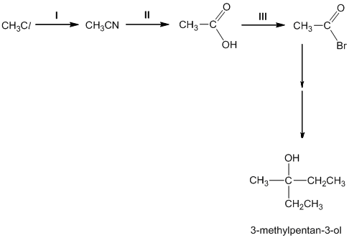
 |  | (i) |  | State the reagents and conditions required for reactions I, II and III.
 |  | (ii) |  | Use the bond energy values from the Data Booklet to explain how the rate of reaction I would change if iodomethane, CH₃I, is used as the starting material.  [6]  [Total: 20]

7 | (a) | Phosphorus is a non-metal discovered by the German physician Hennig Brand in 1669. In his experiments, Brand found that the white material (white phosphorus) glowed in the dark and spontaneously burst into a bright white flame when burned in air.
 |  | (i) | Write equations for the reactions that occur when a sample of phosphorus is burned in excess oxygen, and water is added to the resulting oxide.
 |  | (ii) | Suggest the pH of the aqueous solution formed.  [3]
 | (b) | The equation below shows how phosphorus pentachloride, PCl₅, reacts with a limited amount of water.  PCl₅(s) + H₂O(l) → POCl₃(l) + 2HCl(g)  Given the following data.  Standard enthalpy change of formation of PCl₅(s) = –444 kJ mol^{–1}  Standard enthalpy change of formation of POCl₃(l) = –1186 kJ mol^{–1}  Standard enthalpy change of formation of HCl(g) = –92 kJ mol^{–1}  Standard enthalpy change of combustion of H₂(g) = –286 kJ mol^{–1}
 |  | (i) | What do you understand by the term standard enthalpy change of formation?
 |  | (ii) | Use the energy cycle below and the given data to calculate ΔH_{r}º.  ΔH_{r}º  PCl₅(s) + H₂O(l) POCl₃(l) + 2HCl(g)  P(s) + H₂(g) + ½O₂(g) + Cl₂(g)  [3]
 | (c) | Phosphorus pentachloride, PCl ₅, is involved in the following reaction scheme.
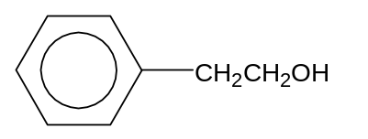 U
W
C₈H₁₁N
PCl₅(s)
I
V
conc. NH₃
heat
Y
II
CH₃O⁻ Na⁺
heat

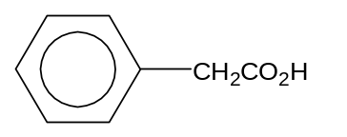 X

 |  | (i) | Draw the structural formulae of compounds V, W and Y.
 |  | (ii) | State the reagents and conditions needed for reaction I.
 |  | (iii) | State the reagents and conditions needed to convert X to U.
 |  | (iv) | Name the type of reaction involved in II.  [6]

(d) | Phosphates have an amazing array of applications in home and industry. For example, sodium hydrogenphosphate, Na₂HPO₄, is a laxative ingredient and is used to adjust the acidity of boiler water.
 | (i) | A buffer solution of H₂PO₄–(aq) and HPO₄^{2–}(aq) can be made by adding a small amount of solid NaOH to an aqueous solution of NaH₂PO₄.  Given: H₂PO₄–(aq) ⇌ H⁺(aq) + HPO₄^{2–}(aq) K_{a} = 6.30 × 10^{–7} mol dm^{–3}  I I Explain what is meant by the term “buffer solution”.  II II Write equations to explain how the addition of a small amount of solid sodium hydroxide to an aqueous solution of NaH₂PO₄ enables it to maintain a fairly constant pH.  [4]
 | (ii) | The structure of hydrogenphosphate ion, HPO₄^{2–}, is as shown.  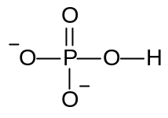  When two hydrogenphosphate ions undergo a condensation reaction, they form a diphosphate ion, P₂O₇^{4–} and a water molecule.
 |  | I | Write an equation for the above reaction.
 |  | II | Draw the structure of P₂O₇^{4–}.
 |  | III | State the shapes and bond angles of the ion about each central atom.  [4]  [Total: 20]
- End of paper -

